**PROJECT 3 – KAPLAN DESIGN**

The aim of this project is to design the distributor, the runner and the diffuser of a Kaplan turbine, including also the control of cavitation in design condition and the efficiency computation.

At the beginning it was suggested to use some statistical correlation in order to evaluate some pre-design parameters, such as the characteristic speed which is in function of the hydraulic head (12 m), of the nominal flow rate(10 m3­­/s) and the rotational speed of the machine. This last parameter is connected also to the number of poles of the generator, which is one of the free variables of this design project. In this case it was chosen a number of pole equal to 8, which will give a rotation speed of 375 rpm at the turbine shaft.

In order to maximize the efficiency, the characteristic speed will define the specific diameter, through the relation expressed in the Bajle diagram. Now all the initial parameters are defined. By means of other correlations, it is possible to obtain, in function of characteristic speed, the geometrical ratio to evaluate the root diameter of runner and the height of inlet section at the wicket gate.

|  |  |
| --- | --- |
| Omega_s | 3,4747 |
| D_s | 1,9 |
| Dt | 1,82 m |
| Ns | 626,54 |
| B/Dt | 0,395 |
| Dr/Dt | 0,42 |

1. **Thomann correlation**

By using a statistical formula, it is possible to determine the number of blades together with the diameter of outlet section of the wicket gate. After solving this simple iterative cycle also the chord value is determined.

|  |  |
| --- | --- |
| Number of blades | 19 |
| Outlet diameter | 2,30 m |
| Chord | 0,53 m |

1. **Wicket gate design**

After the definition of geometrical parameters, it is important to evaluate the right orientation of the profile. To guarantee the conservation of Eulerian work, the tangential components of speed are connected to the radius by a constant ratio. So the velocity at the outlet section of the gate is known a priori. Thrugh a balance of forces derived from aerodynamics of profile used for the blades (NACA0012) and from momentum balance, the incidence angle can be evaluated. The stagger angle is already known thanks to the outlet velocity and the profile is symmetry, so chord and mean line are superimposed. In the end it is important taking in to account the blades interaction with each other. A correlation made by Weining let to adjust the stagger angle in order to reach the same value of lift coefficient of a single blade profile with a cascade. In this case the stagger angle calculated is 33° from tangential direction, 7° lesser than the first value. The code used to evaluate the incidence angle has a problem in its definition: to achieve a convergence it is necessary to decouple the incidence and the value of tangential component of inlet velocity. A strict correlation of them, using the velocity triangles will cause instability in computing and will give always nearly null incidence as result. This problem is very hard to be fixed and will not disappear also putting a relaxation factor on the solution. Probably it’s a problem of the inverse tangent function that will give in some condition numbers no longer connected with the correct orientation of triangles.

1. **Runner Design**

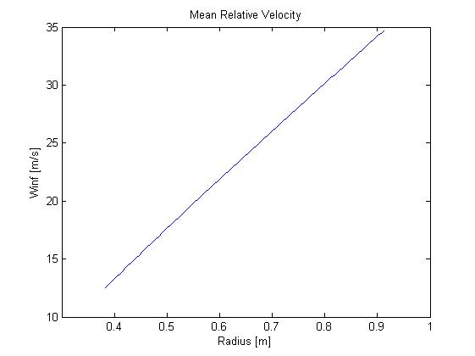The idea is to extrapolate the chord of each section in which blade is divided by balancing the constant Eulerian work by aerodynamic performances of profiles. At first the number of blades is determined by a statistical correlation (in our case, there are 5 blades in the runner) and then all the triangles are calculated along the blade, because they are already defined thanks to the hypothesis of a constant Eulerian work. The point is defining the mean relative velocity angle, because it can not be directly evaluated by the ratio of axial and tangential component, because the sign of the tangential part will also change the result of the inverse tangent function. Thus a control must be added in order to avoid meaningless results. In addition to this, there is another problem: all angles connected to profile and the coefficients are evaluated with respect to the chord of the profile, however the flow will take the direction imposed by the mean line. At the trailing edge the direction of relative velocity is not the same of the chord and so the stagger angle can not be calculated as a simple ratio of axial and tangential components. A correction must be added, which is a deflection of the mean line from the chord at the trailing edge. This correction is different for each profile used in the different part of the blade. Keeping it into account, the balance can be written.

The plot shows how the mean relative velocity will increase linearly with the radius, because the major component is always the tangential velocity due to the runner rotation. A higher value of Winf will also generate higher interaction with the flux and so higher aerodynamic forces: this will cause a chord reduction along the radial direction.

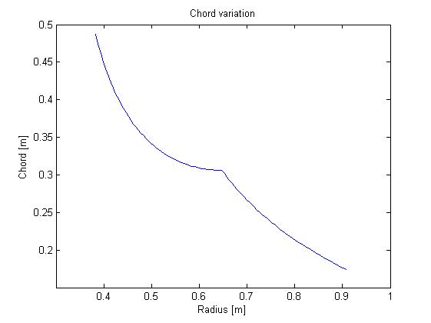

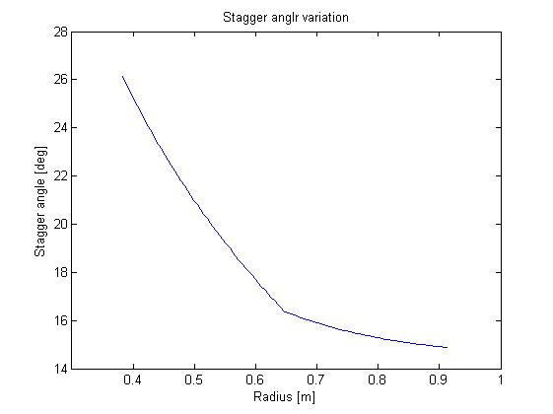In these calculations, the Reynolds number contribution is not considered, because the turbulent condition is always reached for every operating point of the machine and the profiles performances will not change significantly. Also the stall condition is very far in this condition, so it was sufficient to use the performances of profiles measured at Reynolds equal to 106. Together with the chord reduction, also the direction of Winf will always be more tangential, due to an increase of tangential component. So the stagger angle (calculated from negative tangential direction) will reduce along the radius, making the blade rotate around its axis.

In the end also the Weining correction must be applied on the runner. So the new stagger angle will vary from 40 degrees at the hub to 60 degrees at the tip.

1. **Efficiency evaluation and cavitation control**

To conclude the design, it is a good use to control that the final efficiency is close to the value derived at the beginning from Bajle diagram. The losses at wicket gate and diffuser are in function of the kinetic energy of flux. The losses on the runner are calculated using a formula that will keep into account the drag developed by profiles, the solidity of the blades and the deflection of the flux at the outlet.

|  |  |
| --- | --- |
| Wicket gate loss | 0,03 m |
| Diffuser loss | 0,84 m |
| Runner loss | 0,27 m |

The final value of the efficiency is more or less 90% which is quite near to the first value assumed.

To avoid also cavitation problem, it is important to evaluate the height at which the runner has to be installed. This parameter can be evaluated from a Bernoulli balance between the outlet section of runner and diffuser discharge. By definition, the plant provides a NPSH (net present suction head) and it has to be bigger than the NPSH required by the machine to reach cavitation.

The NPSHr is a function of Thoma parameter, derived from statistical approach. Applying this formula to our case, the height required to avoid cavitation is 40 cm under the water level, assuming that the pressure required to gas and vapor to evaporate is about 10000 Pa.